HOW TO – WFM Company and Calendar Configuration (DRAFT)
Contents
How to access the Company and Calendar Configuration Screen 2
How to Add a New Company 2
How to Auto Advance Periods 3
Configuration 4
Summary Tab 4
Company Calendar Years Tab 6
Company Calendar Periods Tab 7
User Defined Periods 9
Rostering Tab 10
Generate Timesheets Tab 11
Absence Parameters Tab 12
Late Parameters Tab 12
Clocking Parameters Tab 12
Company Holiday Absences Tab 13
Settings Tab 14
Flexitime Tab 14
Timesheet Threshold Balance Tab 15
Request Future Absences Tab 15
Trigger Point Groups Tab 16
Sign Off Rules Tab 16
File Locations Tab 17
Banked Hours Parameters Tab 17
Occasional Night Premiums Tab 18
NCHS/Agency Parameters Tab 18
Contract Hours Tab 19
Advanced Options Tab 19

Document Version Control
Change History/Review Details
Date | Version | Review by | Summary of Change
19-Dec-2023 | 1.0 | MJOS | Initial draft following migration of Company and Calendar Config from back office into the Portal

How to access the Company and Calendar Configuration Screen
- Go to the WFM Admin Dashboard.
- Click on WFM Configuration.
- Search for and select Company and Calendar Config.

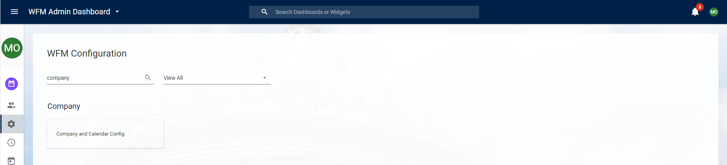
The Company configuration screen shows any existing companies which have been configured on the system.
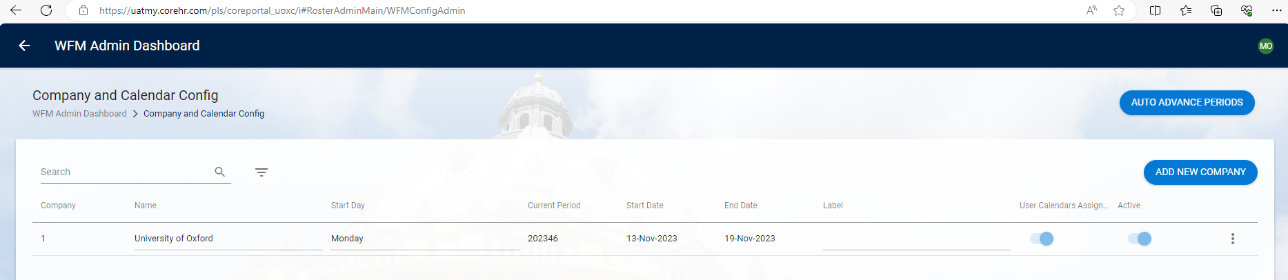
From here you can:
- Search for a specific company, using the search bar or filter.
- Access the configuration screens via the relevant 3-dot menu.
- Set Auto Advance Periods.
- Add a new company.

How to Add a New Company
To add a new company, complete the following steps:
- Click Add New Company.
- Fill in the Mandatory fields and enable the Active toggle, then click OK.
- The 3 Step System Calendar Wizard will open, where you can configure your company.
- In Step 1, Calendar Year, select the System Calendar Year, Start Date of the Company, and the number of weeks in the year. This may vary in a leap year.
- Click Next.
- A message regarding auto generating periods will appear:
- Click Yes if you wish the weeks to autogenerate for you.
- Click No if you wish to do so manually.
- In Step 2, Calendar Period, you can configure the auto rostered weeks for your company. Use the dropdown menu to select the current period, this is the year and week, for example 202320.
- On complete, click Next.
- In Step 3, Company Parameters use the dropdown menus to populate the Mandatory fields. For example, Late Pay Code, Unapproved Absence Pay Code.
- Once you have completed, click Save.
- Your company will now be listed on the Company and Calendar Config screen.

How to Auto Advance Periods
To setup an auto advance for system calendars, complete the following steps:
- Click Auto Advance Periods.
- On the Auto Advance Periods screen, click Add.
- Select the Day of Week and Time for the System Calendars to move forward one period.
- Click OK.
A routine will run that checks if any of your system calendars are in the past. If they are then they will automatically advance one period. This will ensure that your calendars do not fall too far behind the actual date.
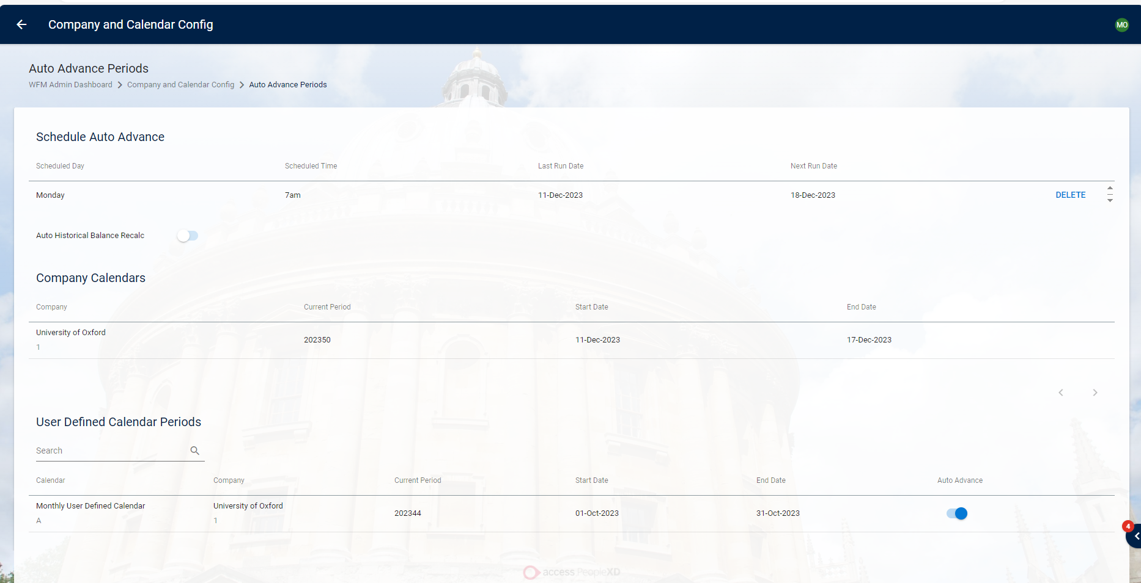
The Auto Advance Periods screen contains the following fields:

FIELD | DETAILS
Schedule Auto Advance | This displays the Auto Advance schedule setup and when the next run date will take place.  Use the Delete button to remove a schedule.
Auto Historical Balance Recalc | By default, the toggle is off, enabling this toggle will recalculate all historical balances at period end. This can add a substantial time overhead to the process and is only advised if there is a specific reason to enable this.
Company Calendars | This lists all Company Calendars(s)
User Defined Calendar Periods | This displays the User Defined Calendars.  Active the Auto Advance toggle for the User Defined Calendar to advance when the Company Calendar, it is attached to, advances.

Configuration
Once the company has been set up, you can access it via the Company and Calendar Config screen. Click the 3-dot menu to View/Edit your selected company.
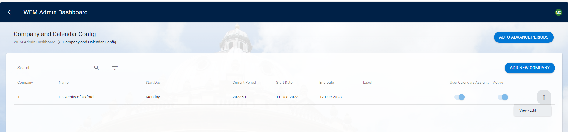
If for any reason you haven’t completed the company setup, on the 3-dot menu it will state Complete Company Setup. You will need to follow and complete the steps How to add a new company, before it can be used.

Summary Tab
The Summary Screen holds all the main information of the company which you have just created.

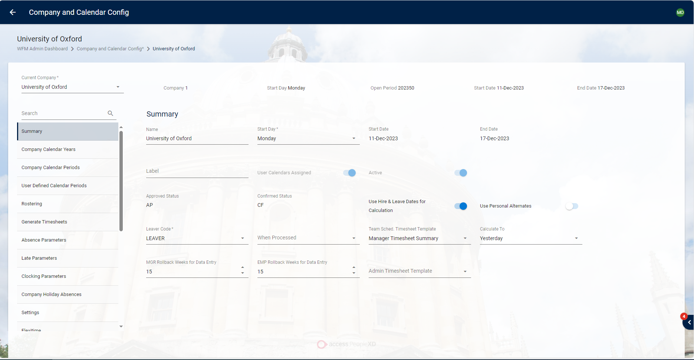
The Summary screen contains the following fields:
FIELD | DETAILS
Name | Name of the company being set up
Start Day | Choose a day of the week for the work pattern to start on, i.e. Monday
Start Date | Start date of the period.
End Date | End date of the period.
Label | You can add a label for the company to be more easily searchable.
User Calendars Assigned | When enabled employees are assigned to a calendar.
Active | When the active indicator is enabled, the company will appear.
Approved Status | This indicator is display only and will automatically insert ‘AP’ into the database as the Approved Status code when hours have been approved through the Maintain Exceptions forms.
Confirmed Status | This indicator is display only and will automatically insert ‘CF’ into the database as the Confirmed Status code when hours have been signed off through the Sign Off Hours form.
Use Hire & leave Dates for Calculation | This indicator, when selected, will use Hire & Leave Dates when calculating hours to prevent any unnecessary unapproved absence from being generated for employees.
User Personal Alternates | This indicator, when selected, will allow employees to change from one work pattern to another for a specific day in the View Work Schedule in the Time Record form, without having to modify the employees shift type.
Leaver Code | This specifies what Employee Status Code, or Personnel Type should be used to indicate an individual who has left the company e.g., LEAVER.
When Processed | Choose between Weekly or Monthly.
Team Schedule Timesheet Template | Input which timesheet template you wish to use, i.e. Manager Timesheet Summary.
Calculate to | Choose between Today, Yesterday and End of Input Period.
MGR Rollback Weeks for Data Entry | Controls the number of weeks back from current period that a manager is permitted to enter data, i.e. 15.
EMP Rollback Weeks for Data Entry | Controls the number of weeks back from current period that an employee is permitted to enter data, i.e. 15.
Admin Timesheet Template | By default, administrators inherit the same timesheet templates as managers. Where required an administrator template can be assigned at the WFM Company level or Username Level which override the default setting when viewing the ‘Timesheet Input’.  - Entry of the Admin Timesheet Template at the username level overrides the WFM Company Level supporting admin staff to have bespoke templates if required.  - If the user also has Managers access assigned, on connection to the Managers Dashboards the manager screens continue to use the managers’ template.

Company Calendar Years Tab
The Company Calendar Years Screen shows the current and previous years of the company and details the start date of the year as well as the number of periods.

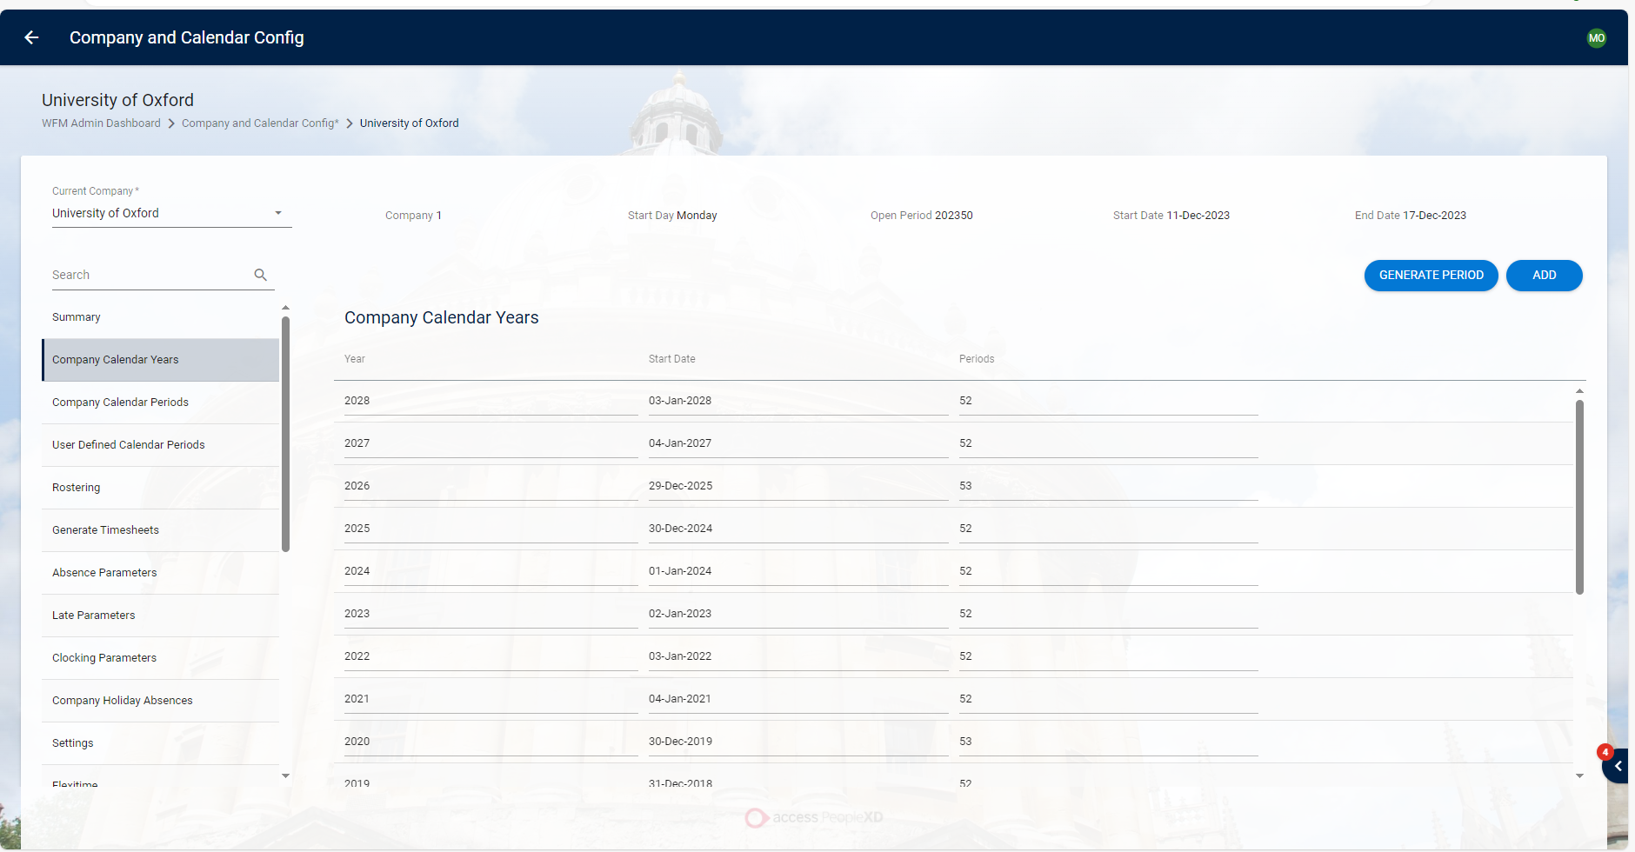
The Company Calendar Years screen contains the following fields:
FIELD | DETAILS
Year | Company calendar year.
Start Date | Start date of the calendar.
Periods | The number of weeks within the calendar year. This may vary depending on whether leap year.

You also have access to the Generate Period & Add buttons. These can be used to:
- Generate Period: The Generate Period button allows you to set up a period by selecting the specific year and setting the fortnightly and monthly starting period.
- Add: This allows you to add a new calendar year to your company.

Company Calendar Periods Tab
The Company Calendar Periods Screen shows all periods that have been generated, historic, future and current.

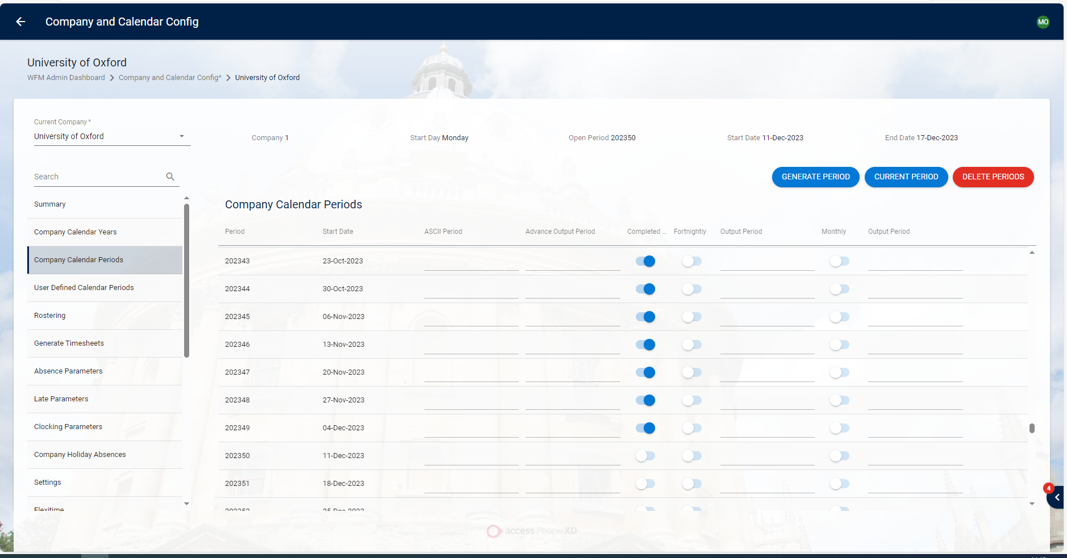
You also have access to the Generate Period, Current Period & Delete Periods buttons. These
can be used to:
- Generate Period: The Generate Period button allows you to set up a period by selecting the specific year and setting the fortnightly and monthly starting period.
- Current Period: This allows you to select the current period and closes off historic periods.
- Delete Periods: If you wish to delete certain periods you can do so with this button.
The Company Calendar Periods screen contains the following fields:
FIELD | DETAILS
Period | This is the 6-digit number which corresponds to the week number on the calendar e.g., 202401 is the first period of the Year 2024.
Start Date | This is the Start Date of the Calendar Period
ASCII Period | Enter in the ASCII number that is sent to payroll e.g., 202401.
Advance Output period | Enter the period which the calendar is to be advance with. The Transaction date of this period entered is then passed to payroll.
Completed Indicator | The completed indicator allows you to close of a period and  designate the current period by enabling the toggle.
Fortnightly | This is selected to indicate the pay week of a Fortnightly pay group. It is only necessary if ASCII payroll is completed on a fortnightly basis. For more information, see the section on the Payroll Interface Set-up
Output Period | This is mandatory if payroll is completed on a Fortnightly basis to specify the output period i.e., the period that the payroll file should be created.
Monthly | This is selected to indicate the pay week of a Monthly pay group. It is only necessary if payroll is completed on a Monthly basis. For more information, see the section on the Payroll Interface Set-up.
Output Period | This is mandatory if payroll is completed on a Monthly basis to specify the output period i.e., the period that the payroll file should be created.

User Defined Periods
The User Defined Periods Screen shows all periods generated for User Defined Calendars.
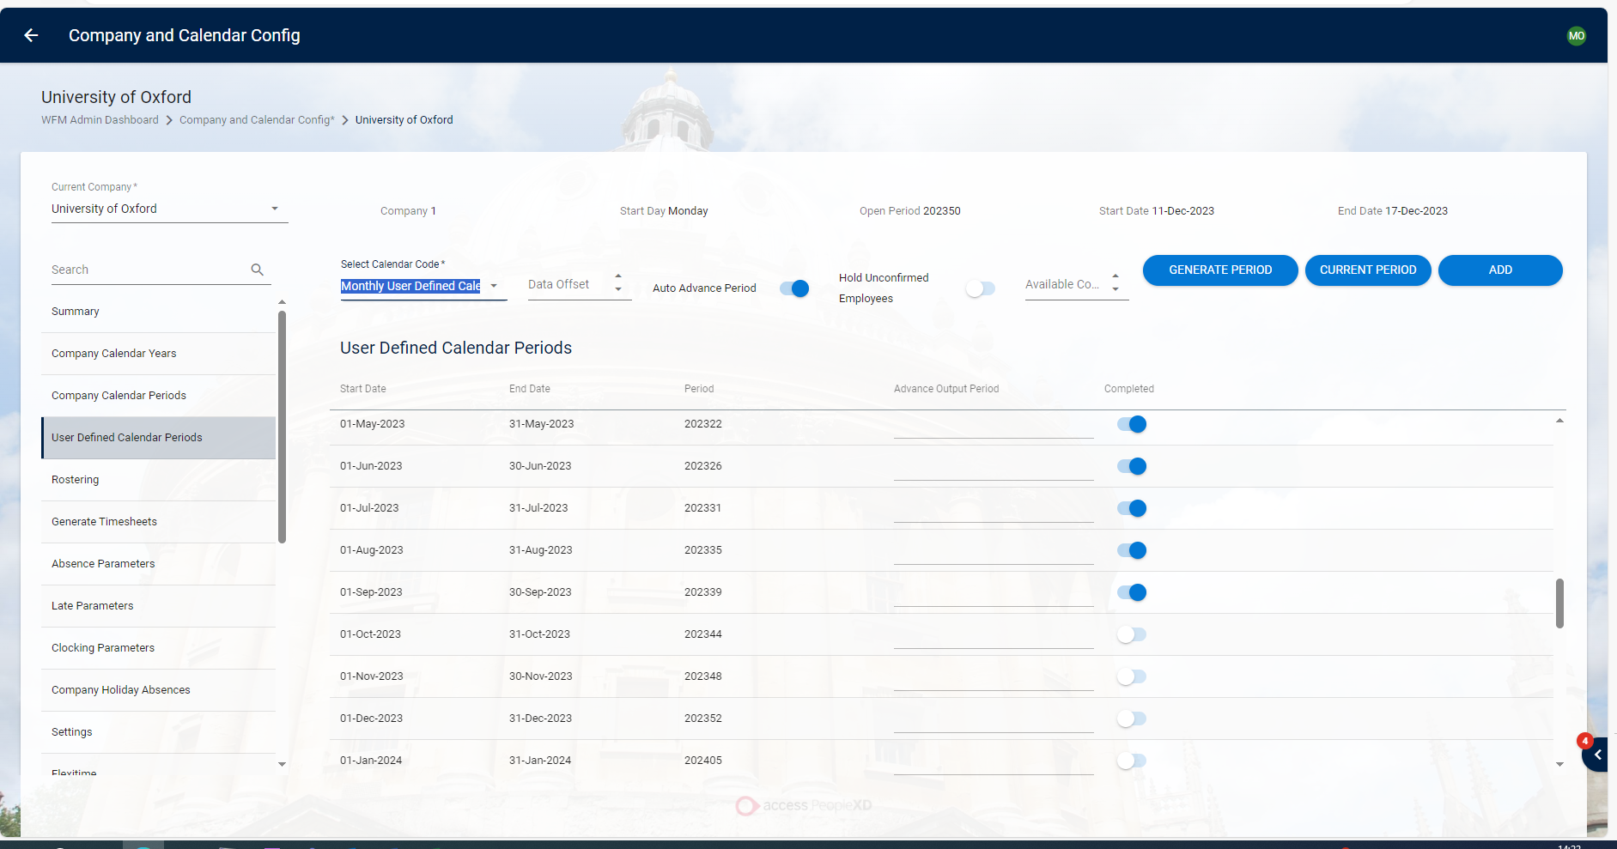
You also have access to the Add button, where you can:
- Add: This allows you to add a new User Defined Calendar Code.
The User Defined Periods screen contains the following fields:
FIELD | DETAILS
Select Calendar Code | You are prompted to select a company calendar. Once selected the periods display and the fields can be edited.
Date Offset | Enter in the number which the Data entry start, and end dates is offset by.
Auto Advance Period | Once enabled, the period is advanced automatically.
Hold Unconfirmed Employees | Turn on to ignore all hours for the period for the person, if any hours are unconfirmed. The hours are paid in a later period when confirmed (Subject to parameter Countback period)
Available Countback Period | Enter in the number of periods back where newly confirmed hours will be processed by generate timesheets. Unconfirmed hours outside of this countback will timeout.
Start Date | Start of the period.
End Date | End of the period.
Period | Specific number assigned to the period by the system.
Advance Output Period | Enter the period which this calendar period is to be advanced with. The transaction date of the period entered is passed to payroll
Completed | This toggle once enabled marks the period as completed.

Rostering Tab
This Rostering screen allows you to configure the controls for the company’s rostering.

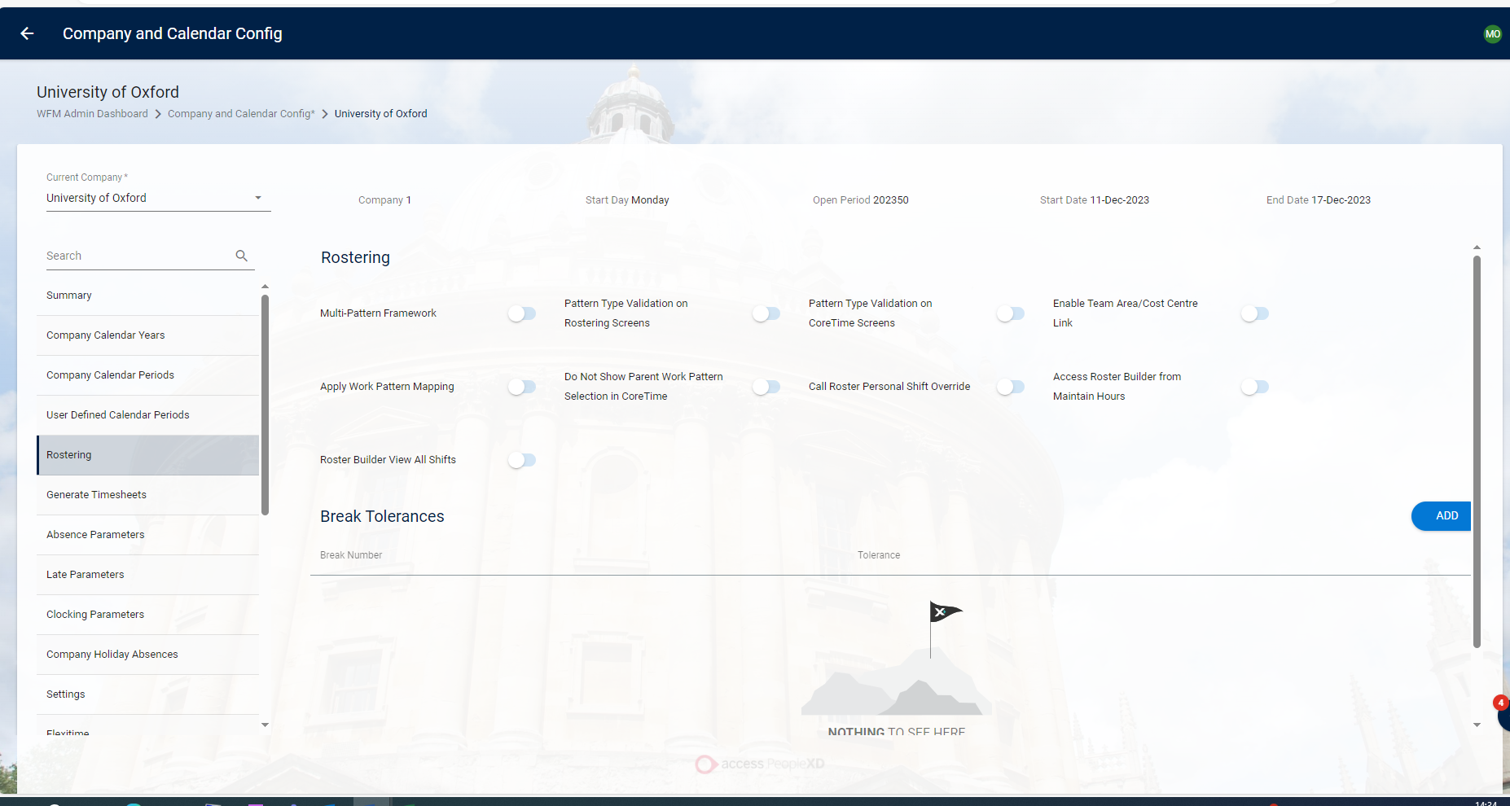

Generate Timesheets Tab
The Generate Timesheets screen allows you to control how timesheets are sent to Payroll for the company. (Previously found under Company Settings)

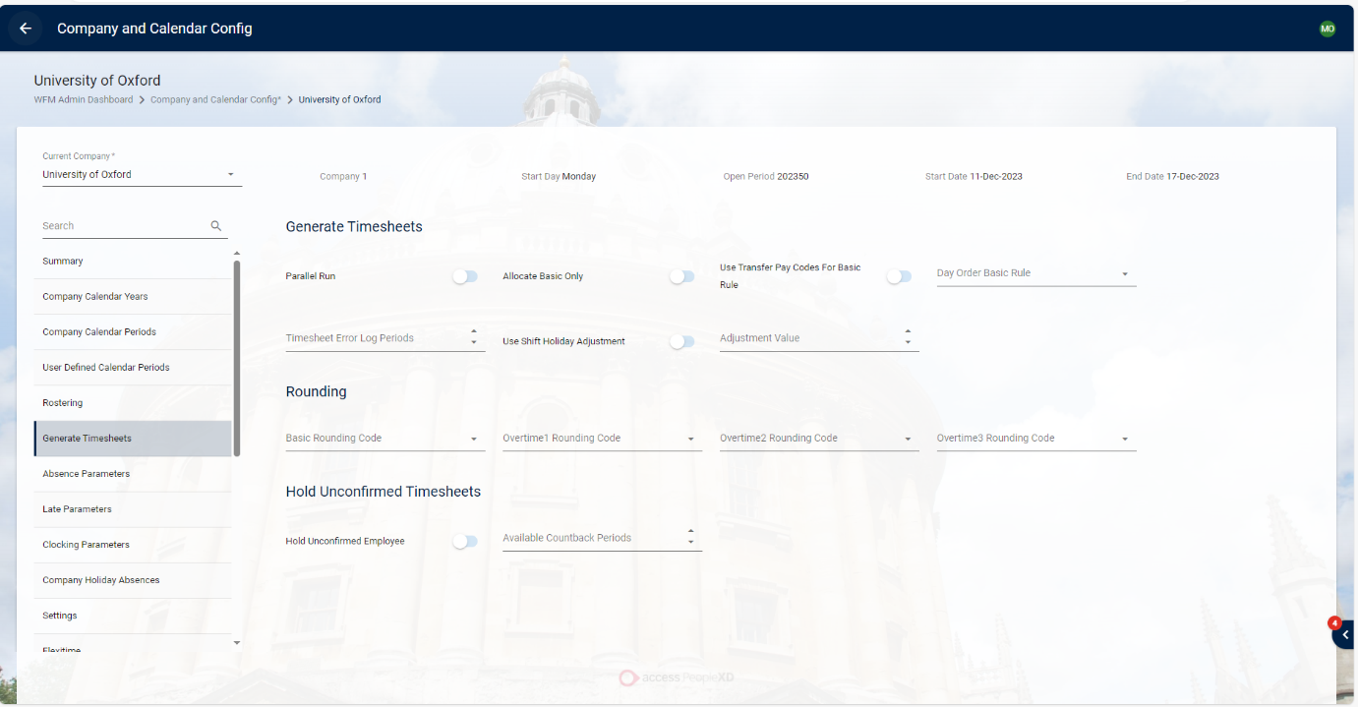

Absence Parameters Tab
The Absence Parameters Screen controls how absences are managed and allows you to assign pay codes and thresholds.
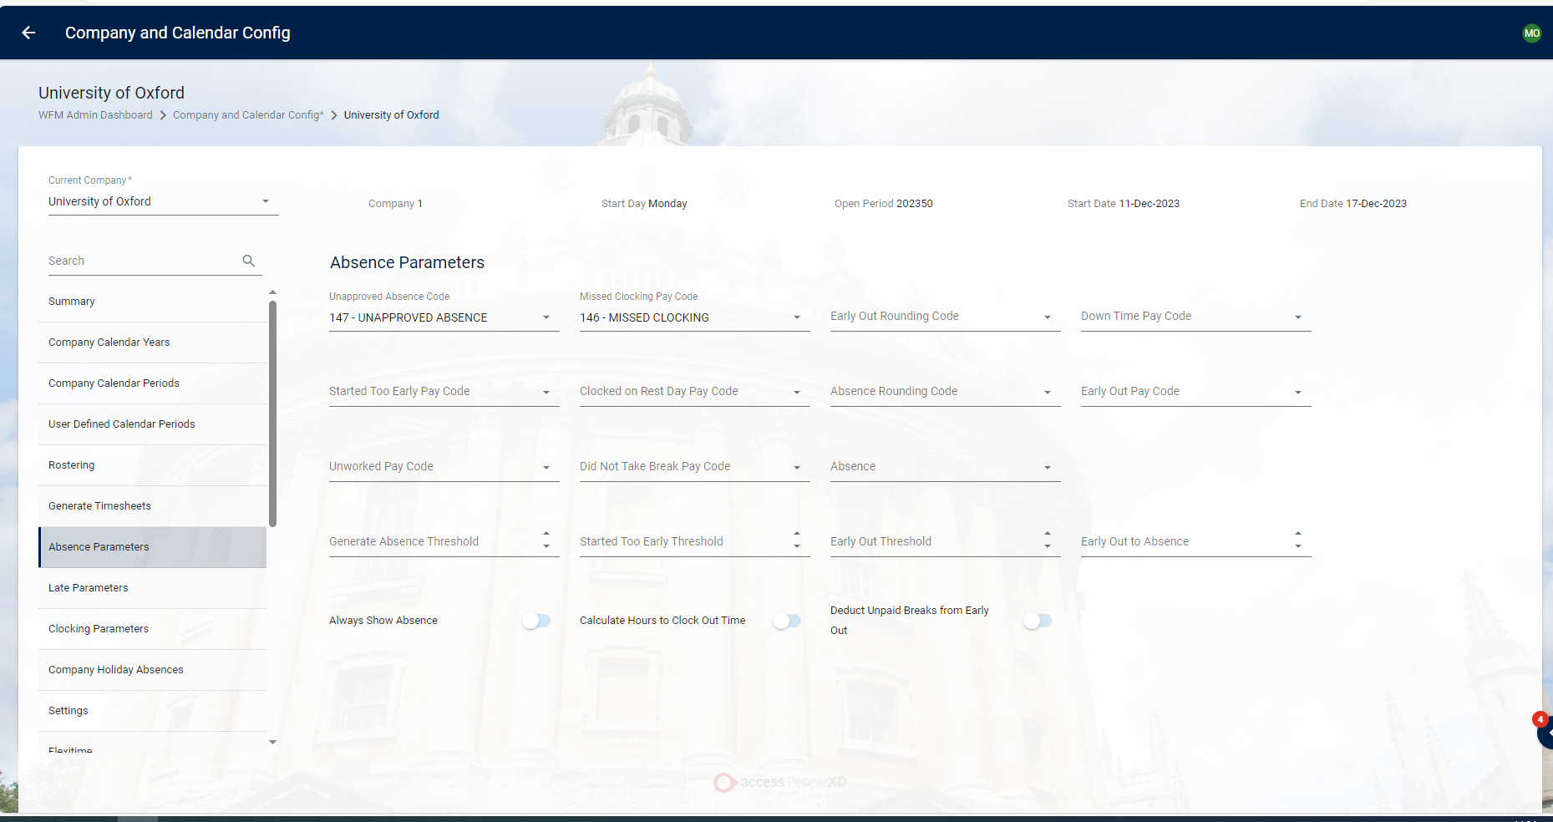

Late Parameters Tab
The Late Parameters Screen controls how lateness is recorded. Here you can apply grace periods and rounding codes for employees.
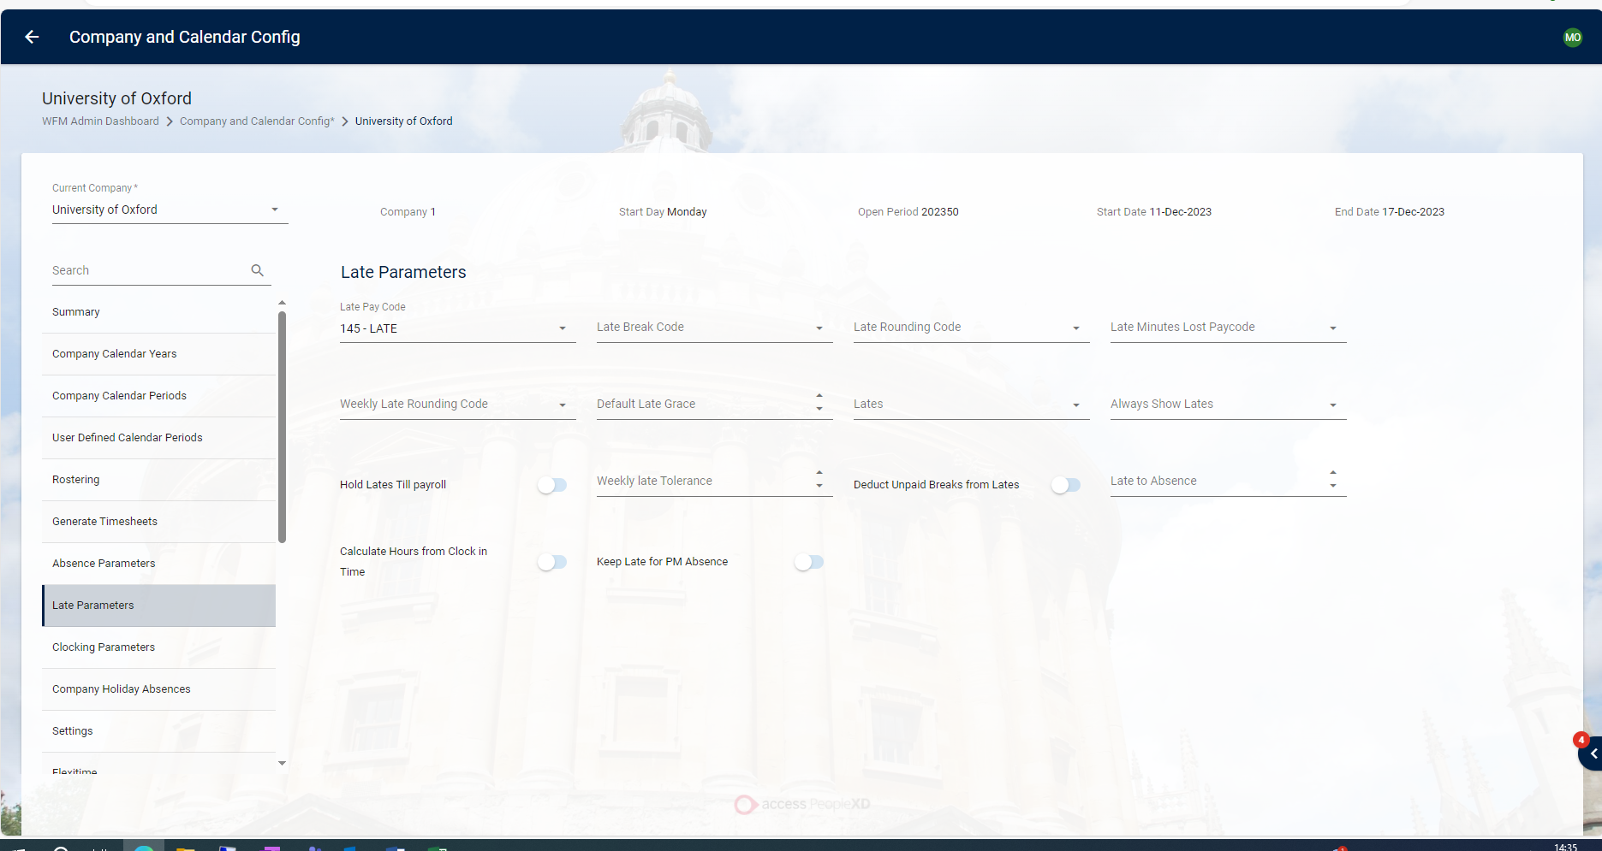

Clocking Parameters Tab
The Clocking Parameters Screen allows you to control employee clocking’s. You can apply
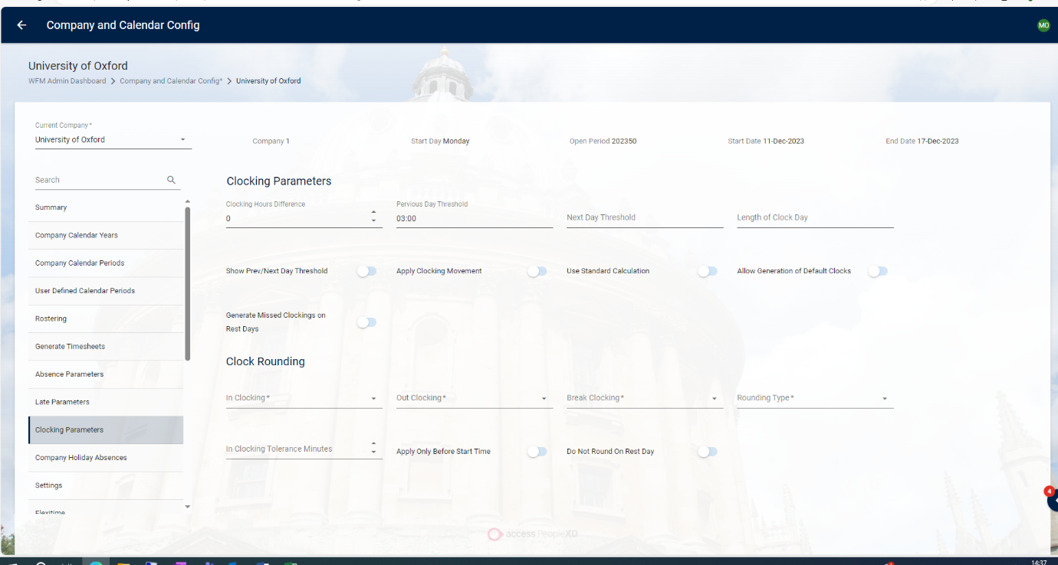
thresholds as well as clock rounding’s using the dropdowns and toggles.

Company Holiday Absences Tab
The Company Holidays Absences screen controls pay codes which can be assigned to company holiday absences.
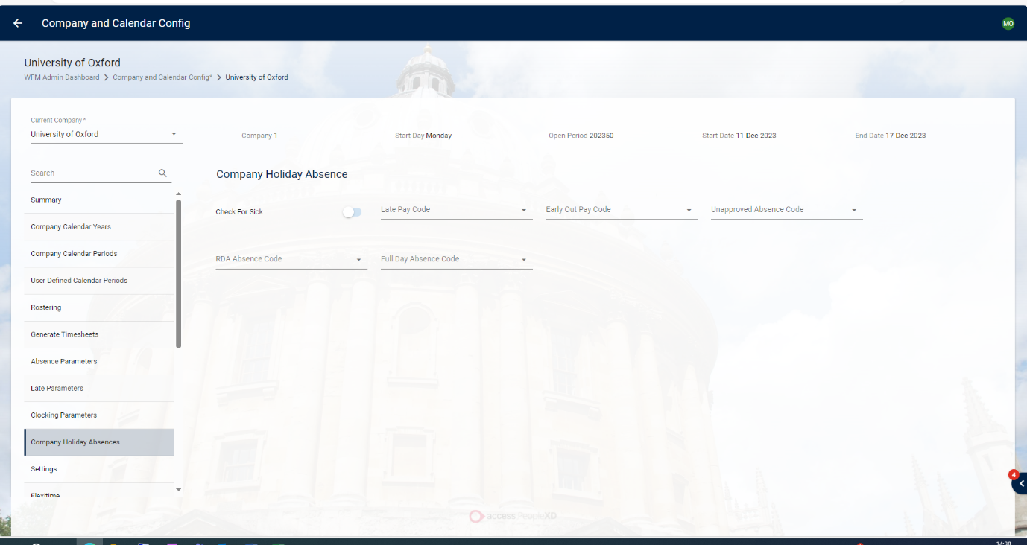

Settings Tab
The Settings screen displays additional calendar setting parameters.
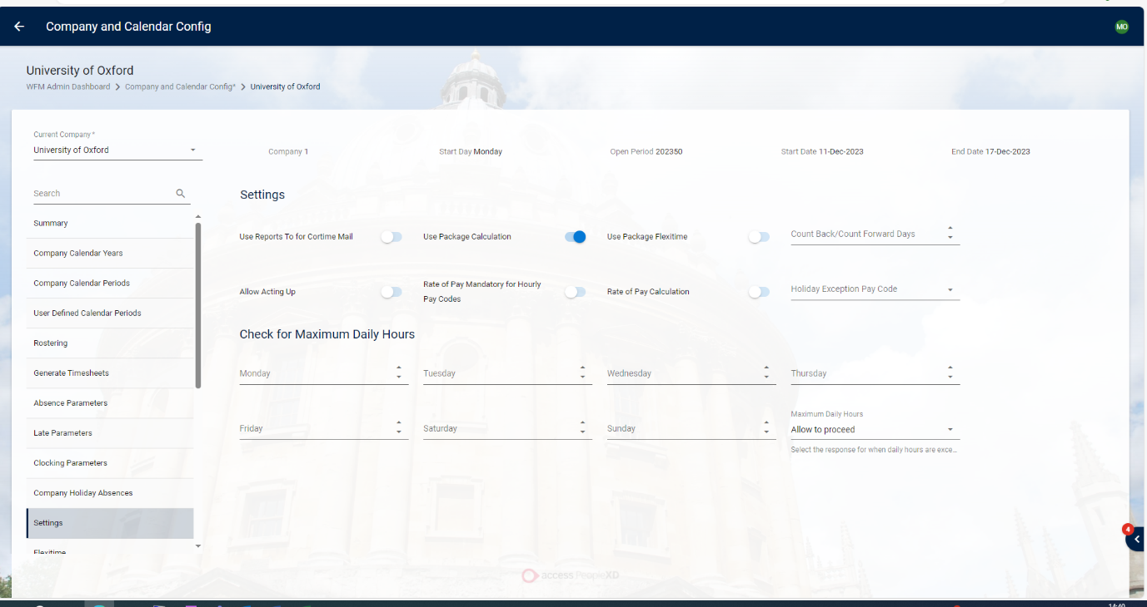

Flexitime Tab
The Flexitime screen displays all the flexitime parameters that can be configured.
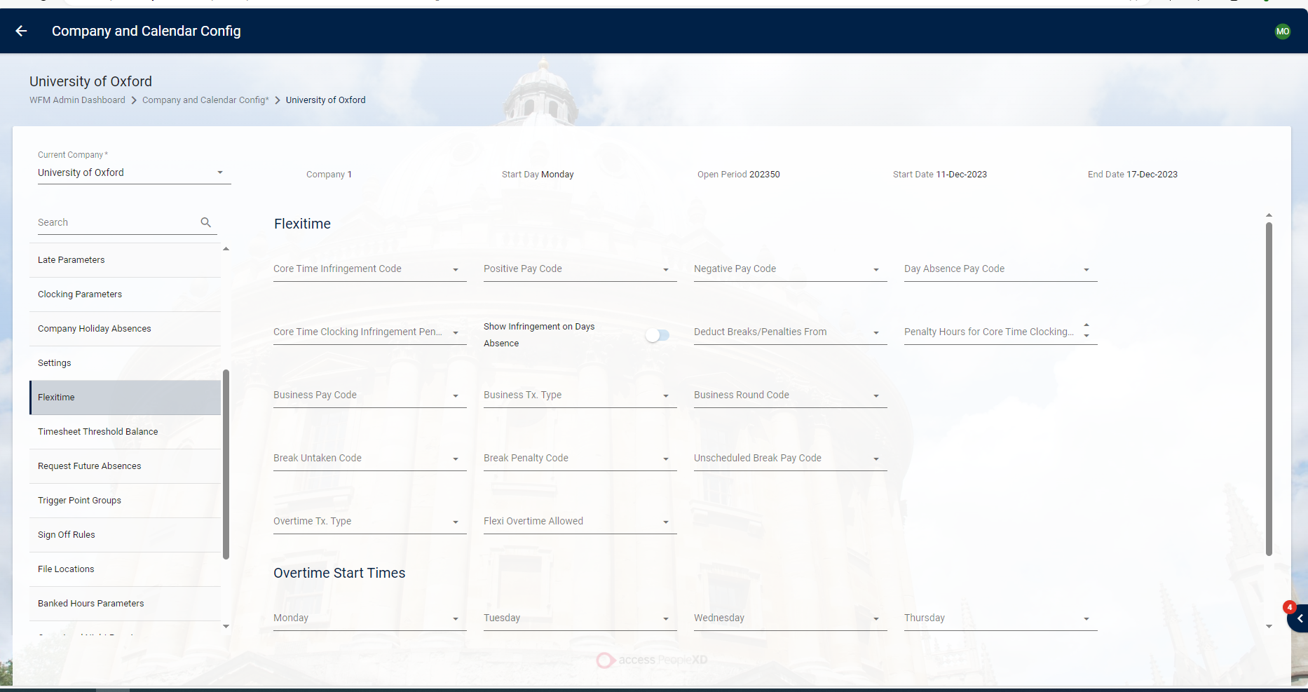

Timesheet Threshold Balance Tab
To set up thresholds to be reached on timesheets, you can use the Timesheet Threshold Balance Screen.
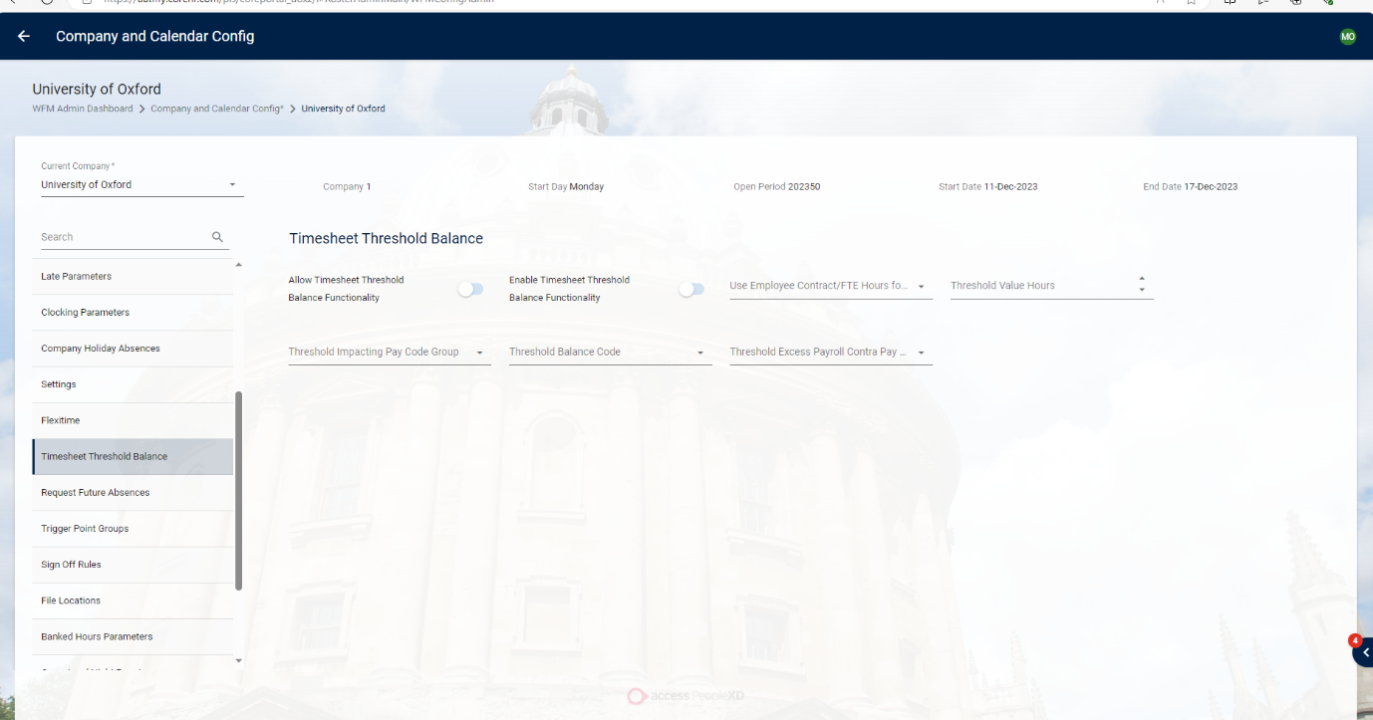

Request Future Absences Tab
The Request Future Absences screen displays all the Future Absence parameters that can be configured.

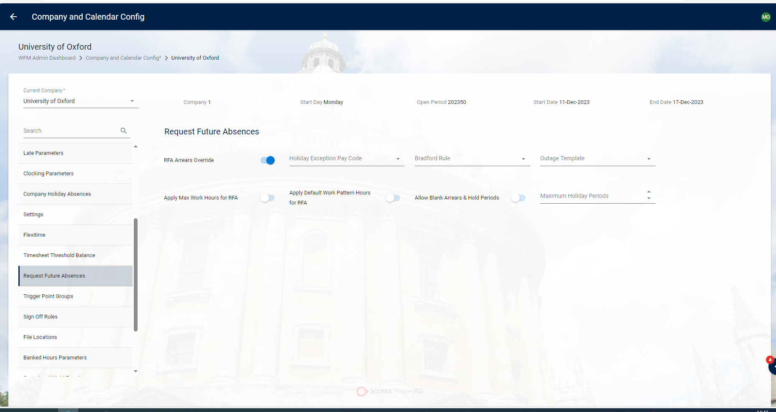

Trigger Point Groups Tab
Trigger Points can be controlled using the Trigger Points Groups Screen.
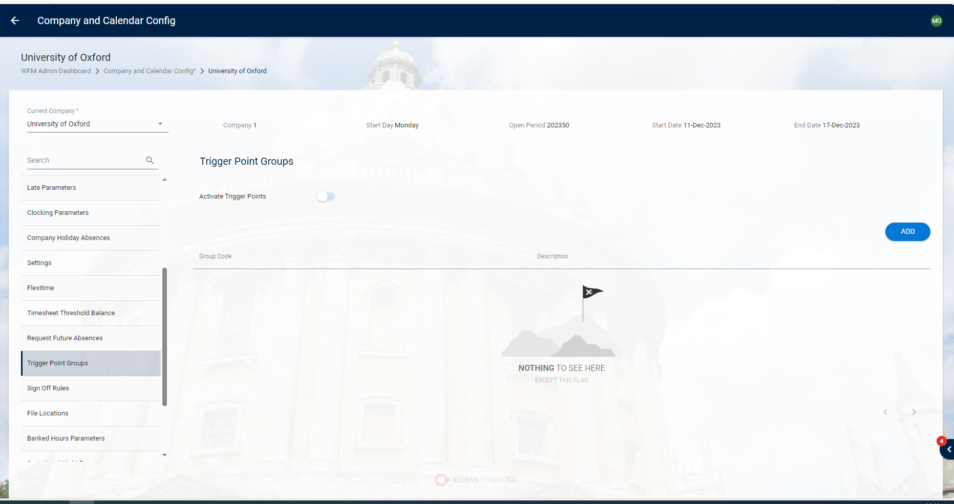
To Add a Trigger Point group:
- Click Add.
- Select the company you wish to use.
- Click Ok
- The Trigger Point Group displays on the screen.
- To delete a Trigger Point Group, click the Delete button.

Sign Off Rules Tab
On the Sign Off Hours screen, you can control how hours are signed off as well as add any rules for the system to follow.
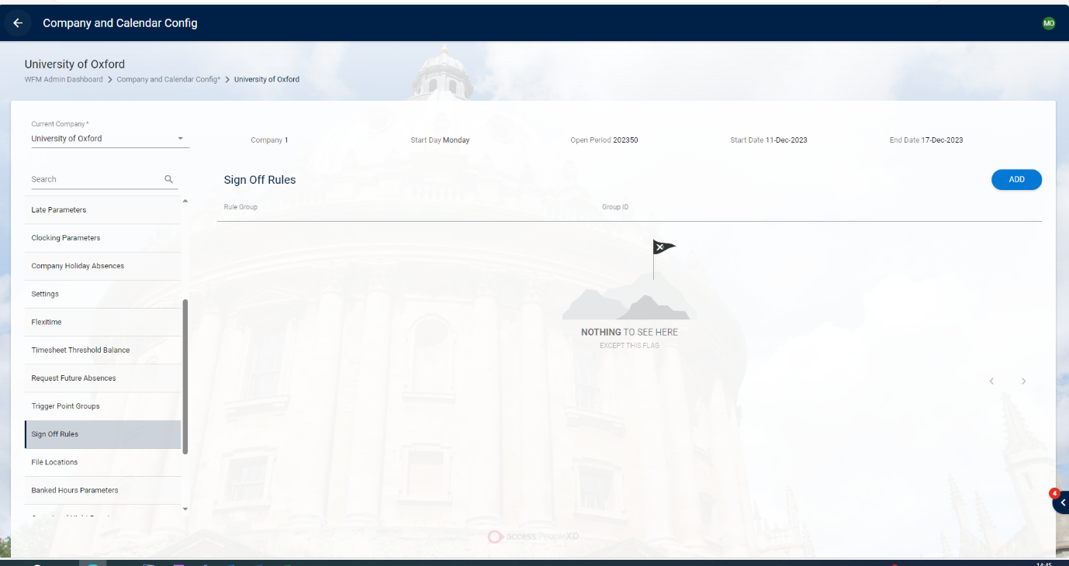

To Add a Sign Off Rule:
- Click Add
- Select the rule from the dropdown menu.
- Click OK.
- The Sign Off Rule displays on the screen.
- To delete a Sign Off Rule, click the Delete button.

File Locations Tab
The File Locations screen
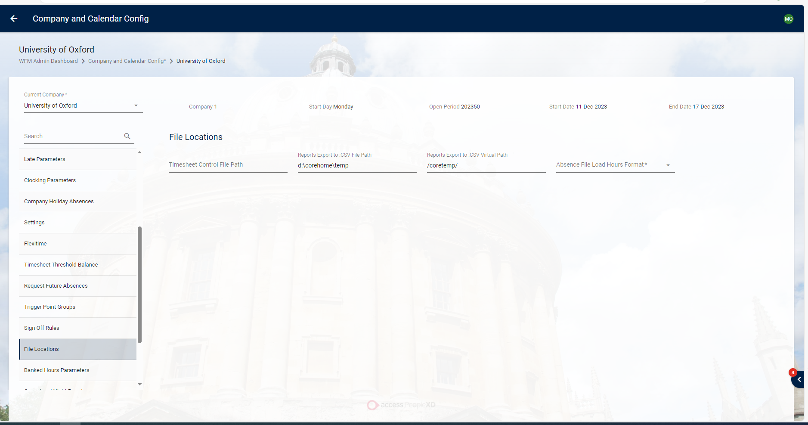

Banked Hours Parameters Tab
The Banked Hours Parameters screen controls the thresholds and pay codes which can be assigned to hour banked by employees in the company.
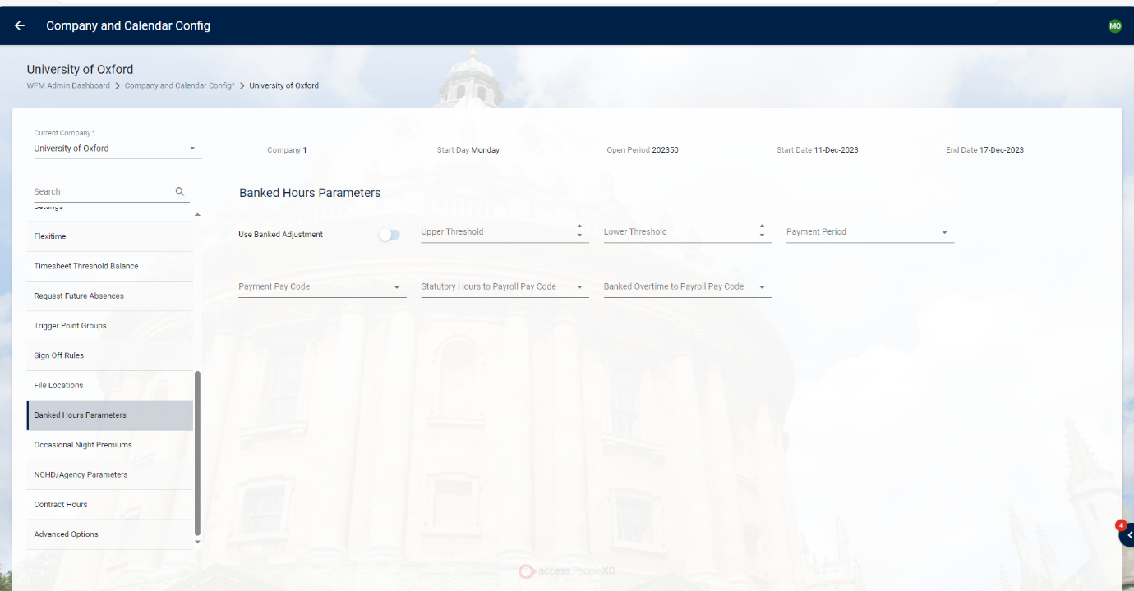

Occasional Night Premiums Tab
The Occasional Night Premiums screen displays all the Occasional Night Premiums created.
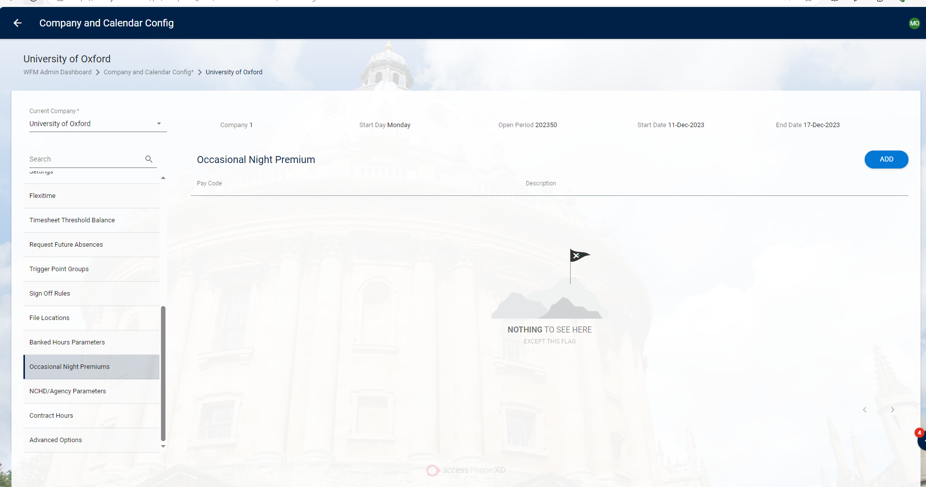
To Add an Occasional Night Premium:
- Click Add.
- Select the pay code.
- Click OK.
- The Premium displays on the screen.
- To delete the premium, click the Delete button beside the premium.

NCHS/Agency Parameters Tab
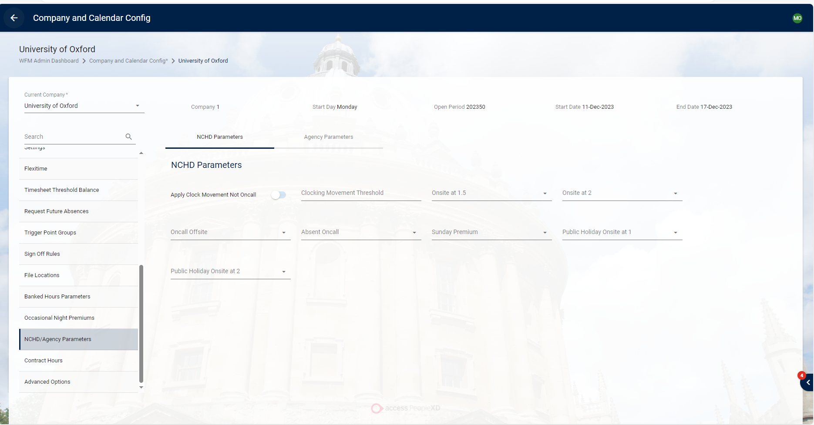

Contract Hours Tab

The Contract Hours screen is used for unrostered hours, to set the days of the week an employee is to work.
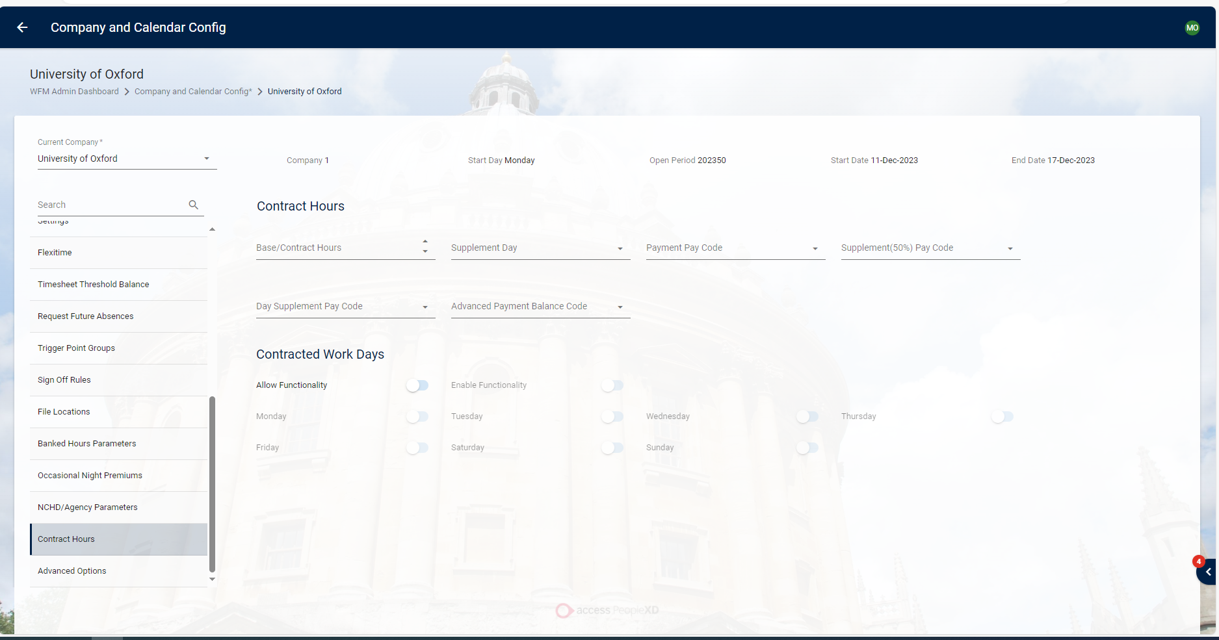

Advanced Options Tab

